Algebraic Expressions- Questions
May 2019 Mathematics Advanced Paper 1: Pure Mathematics 1

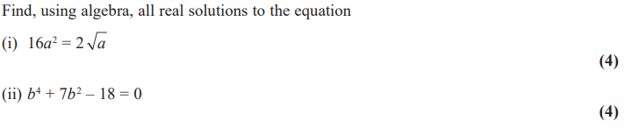

May 2017 Mathematics Advanced Paper 1: Pure Mathematics 1

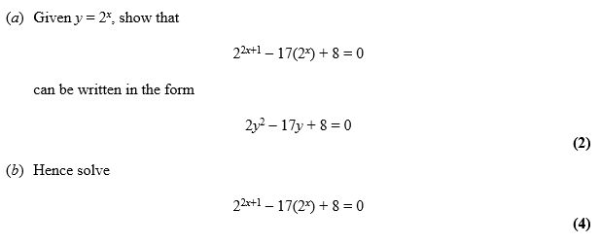

May 2016 Mathematics Advanced Paper 1: Pure Mathematics 1

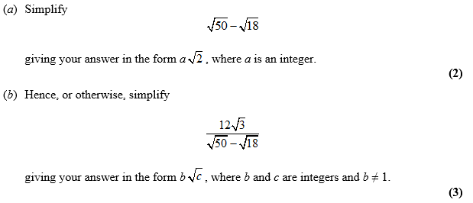

May 2015 Mathematics Advanced Paper 1: Pure Mathematics 1

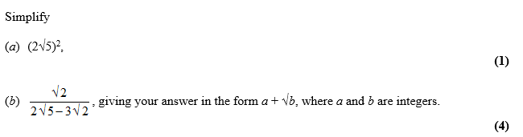

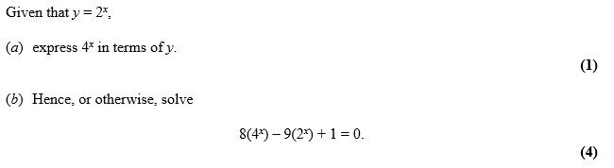

May 2014 Mathematics Advanced Paper 1: Pure Mathematics 1

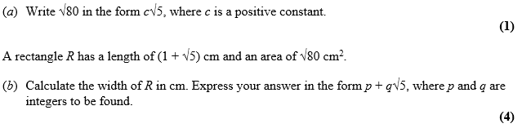

May 2013 Mathematics Advanced Paper 1: Pure Mathematics 1

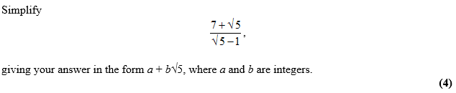

Jan 2013 Mathematics Advanced Paper 1: Pure Mathematics 1

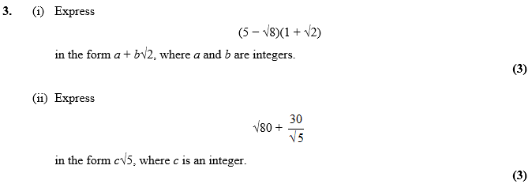

May 2012 Mathematics Advanced Paper 1: Pure Mathematics 1

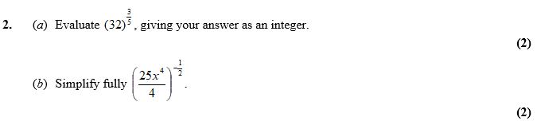

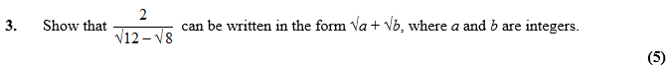

Jan 2012 Mathematics Advanced Paper 1: Pure Mathematics 1

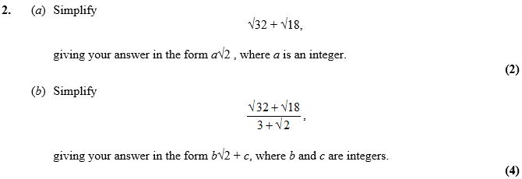
May 2011 Mathematics Advanced Paper 1: Pure Mathematics 1

Jan 2011 Mathematics Advanced Paper 1: Pure Mathematics 1

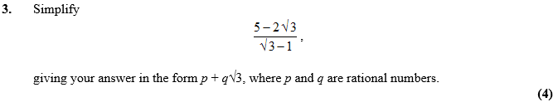

May 2010 Mathematics Advanced Paper 1: Pure Mathematics 1

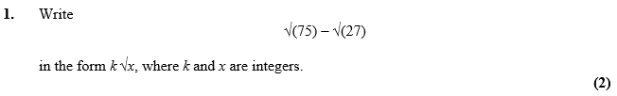

Jan 2010 Mathematics Advanced Paper 1: Pure Mathematics 1

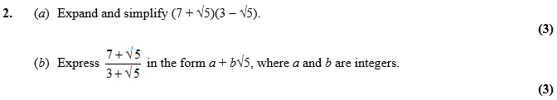

Jan 2011 Mathematics Advanced Paper 1: Pure Mathematics 2

